Template for Evidence(s)
SAMPLE
UI GreenMetric Questionnaire

University : ...
Country : ...
Web Address : …

[1] Setting and Infrastructure (SI)

[1.21] Health infrastructure facilities for students, academics and administrative staffs' wellbeing

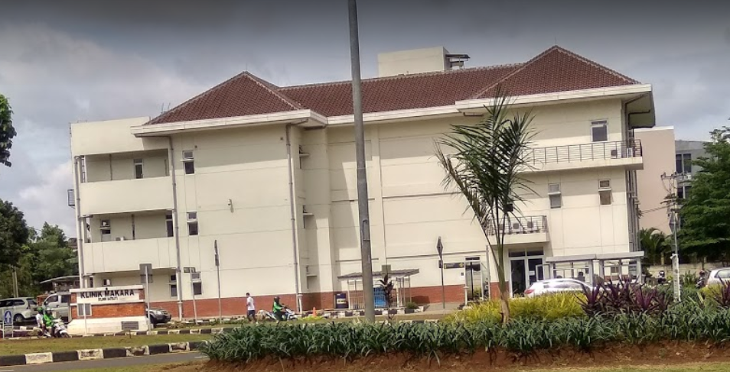
- UI Satellite Clinic

Description:
(Please describe the Health infrastructure facilites in your campus. The following is an example of the description. You can describe more related items if needed.)

- Universitas Indonesia provides health services with comprehensive service support for the entire academic community.

Additional evidence link (i.e., for videos, more images, or other files that are not included in this file):
- https://www.ui.ac.id/layanan/poliklinik.html

