Template for Evidence(s)
UI GreenMetric Questionnaire

University : ...
Country : ...
Web Address : …

[1] Setting and Infrastructure (SI)
SAMPLE
[1.5] Total Campus Area (meter²)

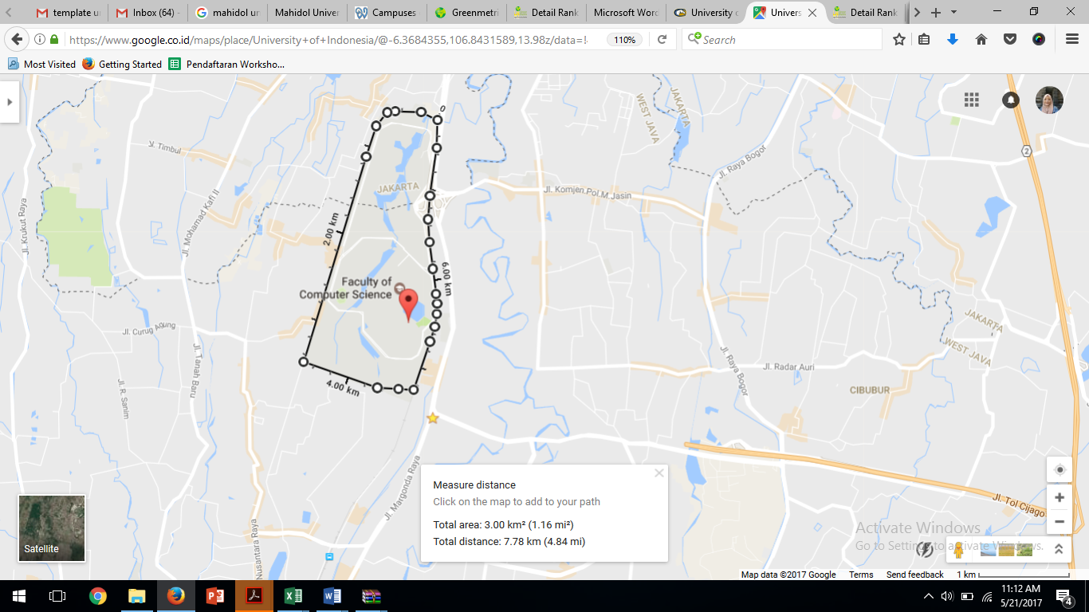
Example of Total Campus Area (Universitas Indonesia, Indonesia)

Description:
(Please describe the total area in your campus. The following is an example of the description. You can describe more related items if needed.)

Total area: 3.00 km² (1.16 mi²) = 3.000.0000 m²
Total distance/circumference: 7.78 km (4.84 mi) = 7.780 m

Additional evidence link (i.e., for videos, more images, or other files that are not included in this file):

