Template for Evidence(s)
UI GreenMetric Questionnaire

University : ...
Country : ...
Web Address : …

[6] Education and Research (ED)
SAMPLE

[6.13] Number of cultural activities on campus (e.g.Cultural Festival) including virtual activities (if any)

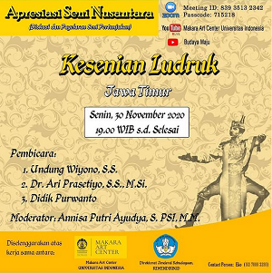 | 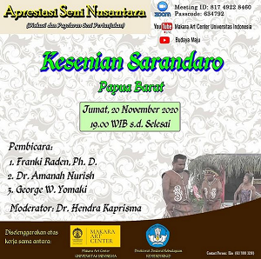
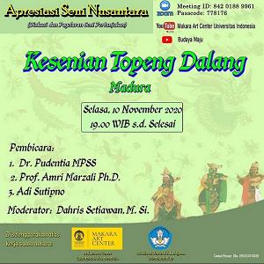 | 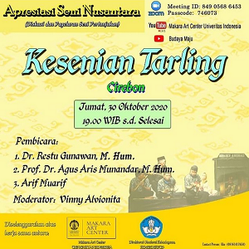
Examples of cultural activities on campus (Universitas Indonesia, Indonesia)

Description:
(Please describe sustainability events on your campus. The following is an example of the description. You can describe more related items if needed.)

Example of Total number cultural activities on campus organized by the University : more than 3 events

Additional evidence link (e.g. for videos, more images, or other files that are not included in this file):

