Template for Evidence(s)
UI GreenMetric Questionnaire

University : ...
Country : ...
Web Address : …

[6] Education and Research (ED)
SAMPLE

[6.8] Number of Events Related to Sustainability

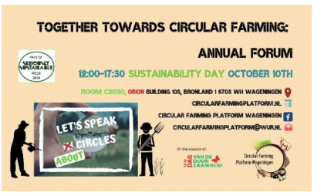 | 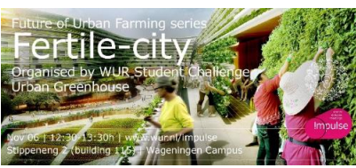
Examples of Events Related to Sustainability (Wageningen University & Research, Netherlands)
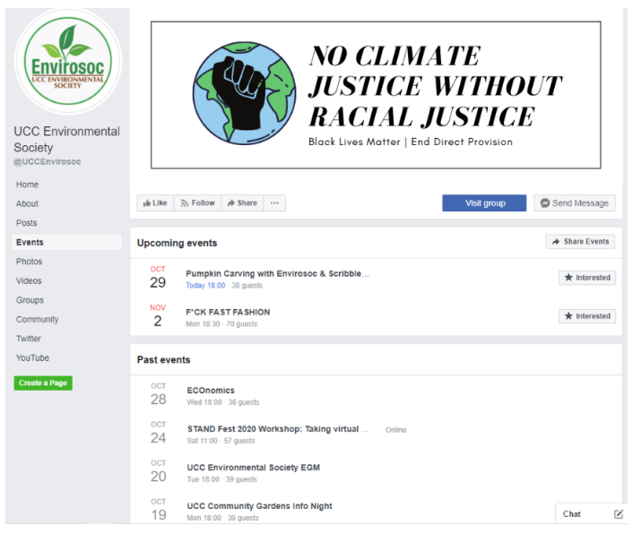
Examples of Events Related to Sustainability (University College Cork, Ireland)

Description:
(Please describe sustainability events on your campus. The following is an example of the description. You can describe more related items if needed.)

Example of events related to environment and sustainability hosted or organized by the University in the academic year 2018-2020.
Total number of sustainability/environment related events in:
2018: 154
2019: 163
2020: 52
A total average per annum over the last 3 years of 123 events (e.g. conferences, workshops, awareness raising, practical training, etc.).

Additional evidence link (i.e., for videos, more images, or other files that are not included in this file):

